

Name:Saira Rehan
Sap Id:55222
Course:Compiler construction
Submission: Lab 5

Task#1:

Code:
%{
#include <stdio.h>

int keyword_count = 0;
int identifier_count = 0;
int operator_count = 0;
int numeric_count = 0;
%}

%option noyywrap

DIGIT [0-9]
LETTER [a-zA-Z]
ID {LETTER}({LETTER}|{DIGIT})*
INT {DIGIT}+
FLOAT {DIGIT}+"."{DIGIT}+

%%

(auto|break|case|char|const|int|float|double|if|else|while|for|return) { keyword_count++; }

{FLOAT} { numeric_count++; }

{INT} { numeric_count++; }

{ID} { identifier_count++; }

(==|!=|<=|>=|=|\+|\-|\*|\/|%) { operator_count++; }

[ \t\n]+ ;

. ;

%%

int main()
{
printf("Enter code (Ctrl+Z then Enter to finish):\n");

yylex();

printf("\nKeywords: %d\n", keyword_count);
printf("Identifiers: %d\n", identifier_count);
printf("Operators: %d\n", operator_count);
printf("Numeric literals: %d\n", numeric_count);

return 0;
}
Output:
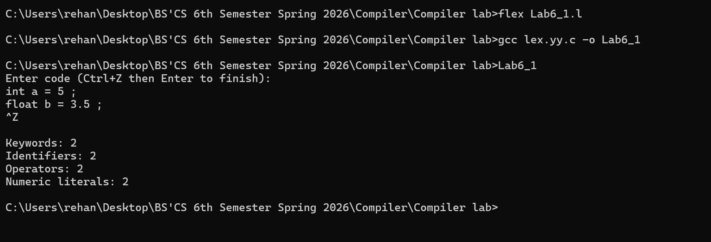

Task#2:
Code:
%option noyywrap
%{
#include <stdio.h>

int line = 1;
int start = 1; // to print line number once per line
%}

%option noyywrap
%x COMMENT

%%

"//".* ; /* remove single line comment */

"/*" { BEGIN(COMMENT); } /* start multi-line comment */

<COMMENT>[^*\n]* ; /* ignore text */

<COMMENT>"*"+[^*/\n]* ;

<COMMENT>\n ; /* ignore newline in comment */

<COMMENT>"*"+"/" { BEGIN(INITIAL); } /* end comment */

\n {
printf("\n");
line++;
start = 1;
}

. {
if(start){
printf("Line %d: ", line);
start = 0;
}
printf("%s", yytext);
}

%%

int main()
{
printf("Enter code (Ctrl+Z then Enter to stop):\n");
yylex();
return 0;
}

Output:
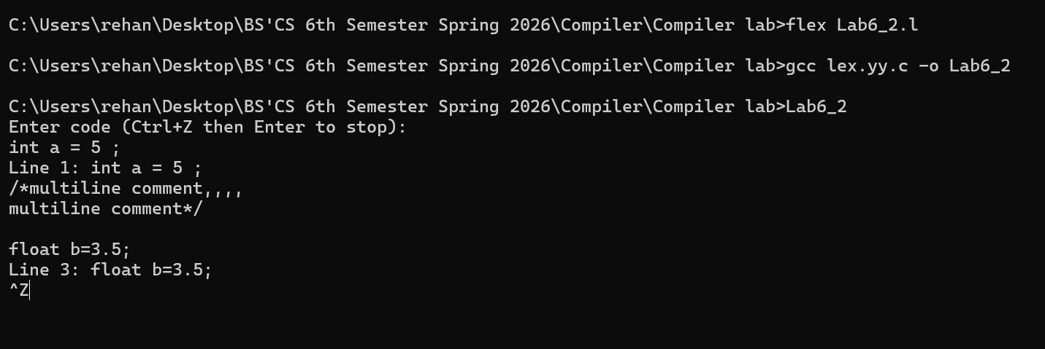

Task#3:
Code:

%option noyywrap
%{
#include <stdio.h>
%}

%%

(\+|\-|\*|\/|%) { printf("Arithmetic Operator: %s\n", yytext); }

(<=|>=|==|!=|<|>) { printf("Relational Operator: %s\n", yytext); }

(\+=|\-=|\*=|\/=|%=|\+\+|\-\-|=) { printf("Assignment Operator: %s\n", yytext); }

[ \t\n]+ ; /* ignore spaces */

. ; /* ignore other characters */

%%

int main()
{
printf("Enter operators (Ctrl+Z then Enter to stop):\n");
yylex();
return 0;
}

Output:

